Three Disk
Magnetic Separator

Operation

Instruction

I, Scope of application
This machine is a dry strong magnetic separator, suitable for ilmenite, rare earth ore, chromite, tungsten, tin, brown iron, niobium, tantalum, zircon, rutile, monazite, andalusite, garnet, lanite, feldspar, stone

Sorting of various magnetically different minerals such as British or removal of iron from non-metallic minerals.
II. Technical Specification
A. CP3—500 Three tape magnetic separator
1, magnetic field intensity：2 mm from the surface of the disc teeth 1700 milliverts
2, No. of Disks: 3pcs
3, Disk Diameter: 500mm
4, Speed of the Disk: 25-40r/m
5, Power: 380 V three-phase four-wire
6, Excitation coils: 4 groups
7, Equipped with motor Y90L-6 0.75kW
8, Excitation power 1.5 kW
9, Coil temperature rises 65℃
10, Coil rated current 1.1 ~ 1.8 amps
11, Use rate continuity
12, Feed Width: 210mm
13, Raw material size <2 mm
14, Capacity： 100 ~ 500 kg/hour
15, Dimension: 2800X800X1220mm
16, Weight: 1900kg

B. CP3—600 Three tape magnetic separator
1, magnetic field intensity：2 mm from the surface of the disc teeth 1800 milliverts
2, No. of Disks: 3pcs
3, Disk Diameter: 600mm
4, Speed of the Disk: 25-38r/m
5, Power: 380 V three-phase four-wire
6, Excitation coils: 4 groups
7, Equipped with motor Y100L-6 1.5KW
8, Excitation power 1.6 kW
9, Coil temperature rises 65℃
10, Coil rated current 1.2 ~ 1.9 amps
11, Use rate: continuity
12, Feed Width: 300mm
13, Raw material size <2 mm
14, Capacity： 100 ~ 500 kg/hour
15, Dimension: 3200X870X1160mm
16, Weight: 2200kg

- CP₃ X-600 Three Disc Rare Earth Magnetic Separator (Type A, B)
1, magnetic field intensity：2 mm from the surface of the disc teeth 1800 milliverts
2, No. of Disks: 3pcs
3, Disk Diameter: 600mm
4, Speed of the Disk: 22-32r/m
5, Power: 380 V three-phase four-wire
6, Excitation coils: 4 groups
7, Equipped with motor Y100L-6 1.5KW
8, Excitation power 1.6 kW
9, Coil temperature rises 65℃
10, Coil rated current 1.2 ~ 2.2 amps
11, Use rate: continuity
12, Feed Width: 300mm
13, Raw material size <2 mm
14, Capacity： 80 ~ 800 kg/hour
15, Dimension: 3200X870X1250mm
16, Weight: 2300kg

III, Main structure
The main machine is composed of ore feeding device, weak magnetic roller, transmission part, material conveying device, disk, electromagnetic system, frame and so on. The electric control part is composed of control, voltage regulation, rectification, instrument and other components. Compact structure, stable performance, easy installation, easy to use and maintain.
IV. Installation
1,All new installation or installation after relocation, it is necessary to carry out routine inspection of the mechanical and electrical parts, and pay attention to whether the parts are damaged, loose, damp, etc. Place the magnetic separator horizontally.
2,Install the electrical console in a place that is easy to operate and observe. Connect the ground wire as usual.
3,The knife switch outside the console is connected to the 25 amp fuse, the four core of the power supply is the black line in the cable and the zero line, the connection between the host and the console is connected by the same number
V. Operation
1,The dry material is sieved and loaded into the feed hopper. Particle size <2 mm
2,Adjust the working gap of the disk according to the ore type, particle size and sorting requirements.
3,Close the knife switch, supply power to the console.
4,Turn on motor and magnetic field switch. The voltage regulator is set to the right current.
5,Open the feed valve so that the material is evenly scattered on the transport belt
6,Stop feeding before stopping.
7,When there are not many magnetic minerals in the raw material, the feeding layer should be thinner to improve the recovery rate and the magnetic mineral content
Over time, the feeding layer can be thicker
8,When the working gap of the disk is fixed, the magnetic field intensity can be adjusted by changing the current; When the current is constant, adjust the working gap of the disk to adjust the magnetic field strength.
9,The processing of magnetic minerals and the selection of magnetic minerals with a weak magnetic field, the processing of magnetic minerals and the scanning of a strong magnetic field.
10,The size of the disk working gap is determined by the size of the ore particle size and beneficiation requirements, which is larger when dealing with coarse grade and smaller when dealing with fine grade. When scanning, the gap is reduced to improve the recovery rate, and when selecting, the gap is increased to improve the grade of the magnetic product, but at the same time, the current is increased to compensate for the low magnetic field strength due to the increase of the disk working gap. It is required that there is a clear space between the disk teeth and the ore on the transport surface.
11,Comprehensive consideration of machine adjustment and beneficiation operation, according material grade, recovery rate, processing capacity and so on.
VI. Attention
1,When the magnetic separator is working, the strong magnetic tools and items should not be close to the magnetic system, and the operator should not touch the rotating parts and wire joints to avoid safety accidents
2,When adjusting the working gap of the disk, the disk tooth tip should be kept at an appropriate distance from the conveyor belt to avoid damaging the conveyor belt.
3,During the operation of the magnetic separator, do not let the motor work without phase. When the motor running sound is abnormal, it should be stopped in time to check the power line

VII. Maintenance and repair
1,Pay attention to abnormal sound, vibration, heat, check and deal with the problem in time.
2,Clean and fill calcium base grease annually
3,Pay attention to the electrical part of the wire is loose, damp, heat, oxidation, keep clean

VIII. Trouble shooting
NO. | Trouble Unit | Fault Phenomenon | Trouble cause | Elimination Methods
1 | Electric | The voltage and current data are abnormal | The power supply quality problem，Electrical meter, electrical part damaged | Check and coordinate resolution,Inspection, repair, replacement
2 | Electric | electric leakage | The wires are broken, touching the iron | troubleshooting
3 | Electric | The contactor stops or fails to close | Supply voltage is too low，The coil burns out，The neutral line is not connected | Increase supply voltage  switch  Connect the zero line
4 | Electric | The maximum direct current is halved | One of the rectifier lines is out | Replace
5 | Electric | fuse blown | Rectifier tube breakdown,The circuit or coil is short | Replace,Inspection and repair
6 | Electric | Magnetic direction confusion | The coil connector is loose and the open DC line is improperly connected | Twist the connector，Pairing line
7 | Electric | The regulator sparks | The local coil is burned out，The sliding surface is convex and concave，The brush is burnt out | Repair and replace，Smooth with water sandpaper
8 | Electric | the indicator light is not on | Power failure，Indicator light broken | Check and repair and replace
9 | Machine | Transport belt and drive belt slip | The tape is not tight | Adjust ejector screw
10 | Machine | The conveyor belt is not operating properly | Transport wheel axes are not parallel | Adjust ejector screw
11 | Machine | Reducer failure | Bearing or gear damaged | Check and repair and replace
12 | mineral separation | Uneven material on conveyor belt | The loose material plate of the circular nozzle bucket is not adjusted properly, and the groove of the nozzle bucket is uneven | Adjust the leveling plate
13 | mineral separation | The wrong mines were taken out | overproduction；Too coarse or too fine；The disk working gap is too small  The magnetic field is too strong；Particle pollution  coenobium | Feed reduction；Sift the raw materials；Raise the disk;Reduce the magnetic field strength；Cleaning,Crushing dissociation
14 | mineral separation | overproduction | Overfeed | Adjust the feed control valve
15 | mineral separation | underyield | underfeed | Adjust the discharge control valve

IX. Electrical Element Sheet
NO. | NAME | Symbol | ITEM NO. |  | UNIT | QTY
1 | Fuse Plug | RD₁4 | RL₄-30A |  | pce | 4
2 | Fuse Plug | RDs-8 | RL₁-15A |  | pce | 4
3 | Pilot Lamp | HD、LD、XD | AD11-25/40380V |  | pce | 3
4 | pushbutton switch | TA QA | LA₂-380V,5A |  | pce | 4
5 | AC contactor | IC 2C | CJ1q-10A,380V |  | pce | 2
6 | Motor | D | Y100L-6 1.5KW |  | pce | 1
 | AC. voltmeter | V |  | 450V | pce
7 | AC. voltmeter | ~ | 44L-- | 300V | pce | 2
 |  |  | TDGC2J-2
8 | AC Voltage Regulator | BT | 220V,2KVA |  | pce | 4
9 | Electrical resistor | R | RXY30W,50Q |  | pce | 4
10 | Capacitor | C | CBB61500V 2uf |  | pce | 4
11 | DC ammeter | A | 44C23A |  | pce | 4
12 | Magnetic field coil PIC | B |  |  | Goup | 4
13 | Silicon rectifier | D | 2CZ800V 10A |  | pce | 16
14 | Rubber switch | KD user-supplied | 500V 30A |  | pce | 1

XI.Electrical schematic diagram
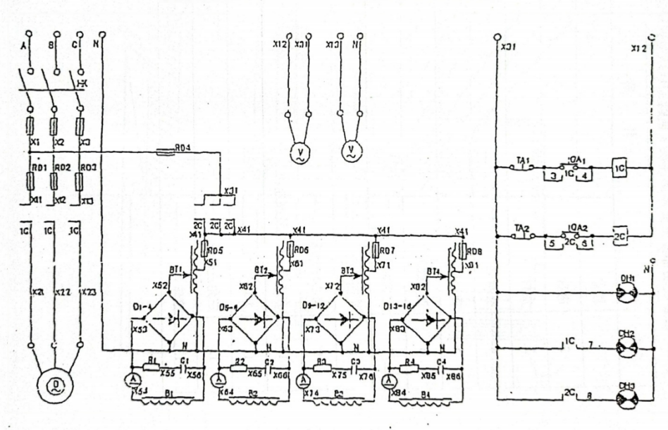

XII.Disk rotation part of the main parts list
1,Baffle cover 2,Disk 3,Oil seal
4,Bearing frame 5,Annular ball bearing 6,Adjusting screw nut
7,Vertical barrel 8,Plane bearing 9,Annular ball bearing
10,Vertical spiral bevel gear reduction box 11,Main Bearing
12,V-belt pulley 13,Ball

XIII.Disk rotation part structure diagram
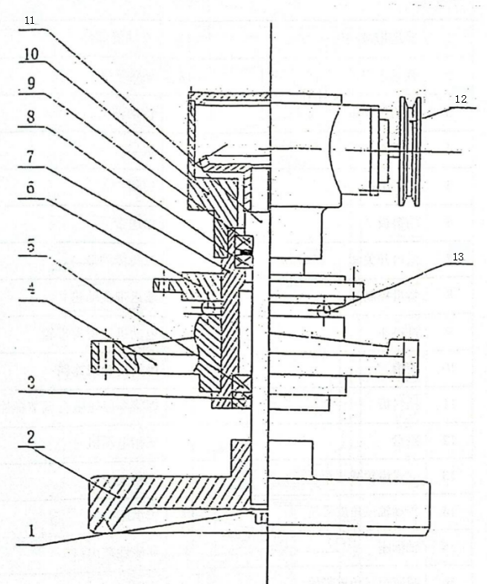

XIV,Magnetic separator assembly schematic parts name sheet
NO. | NAME | NO. | NAME
1 | Conveyor belt passive wheel | 17 | Vertical shaft cylinder part
2 | outlet | 18 | Magnetic ore bucket
3 | Triangle belt | 19 | transmission shaft
4 | bearing housing | 20 | Rack
5 | Weak magnetic roller | 21 | Coil
6 | Levelling plate | 22 | Conveyor
7 | Feed switch valve | 23 | Triangle belt
8 | Feed control valve | 24 | Conveyor belt driving wheel
9 | Feed Hopper | 25 | Motor triangle pulley
10 | Chute | 26 | Horizontal gear reduction box
11 | Striker plate | 27 | Screw bevel gear mesh adjustment bolt
12 | Disk | 28 | Three-phase motor
13 | Vertical gear reduction box | 29 | triangle belt
14 | Drive shaft triangle pulley | 30 | bearing housing
15 | bearing housing | 31 | Non-magnetic ore outlet
16 | Reducer triangle pulley

XV,Magnetic separator assembly indication diagram
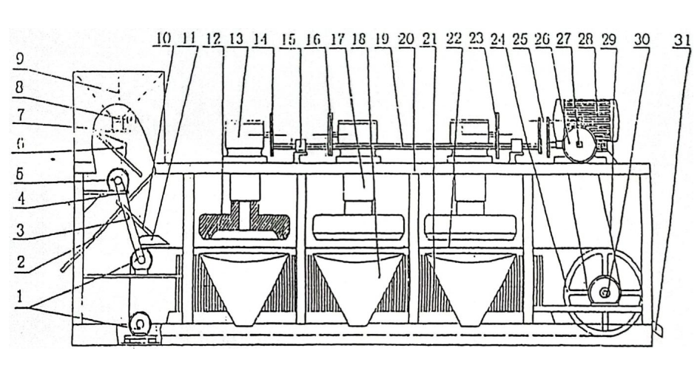

XVI,Wearing parts list
CP₃—500 |  |  |  | CP₃—600
Name | Item No. | Installation site | QTY | Name | Item No. | Installation site | QTY
Bearings | 8211 | Vertical Cylinder | 1 | Bearings | 8211 | Vertical Cylinder | 1
Bearings | 211 | Vertical Cylinder | 6 | Bearings | 211 | Vertical Cylinder | 6
Oil Seal | 55×100×12 | Vertical Cylinder | 3 | Oil Seal | 55×100×12 | Vertical Cylinder | 3
Bearings | 305 | gear casing | 4 | Bearings | 305 | gear casing | 4
Bearings | 206 | gear casing | 6 | Bearings | 206 | gear casing | 6
Bearings | 308 | transmission shaft | 2 | Bearings | 308 | transmission shaft | 2
Bearings | 306 | Conveyer wheel | 2 | Bearings | 306 | transmission shaft | 2
Bearings | 206 | Small conveyor roll | 4 | Bearings | 206 | Small conveyor roll | 4
Bevel gear disc | 43teeth | gear casing | 4 | Bevel gear disc | 43teeth | gear casing | 4
Bevel gear lever | 8teeth | gear casing | 4 | Bevel gear lever | 8teeth | gear casing | 4
triangular belt | A1067 | Disk | 3 | triangular belt | B1118 | Disk | 3
triangular belt | A1422 | Motor | 2 | triangular belt | A1422 | Motor | 1
triangular belt | A1372 | Motor | 1 | triangular belt | B1422 | Motor | 2
Feed belt | 280 | Conveyer wheel | 1 | Feed belt | 360 | Conveyer wheel | 1
Loose band | A | Conveyer wheel | 1 | Loose band | B | Conveyer wheel | 1
Loose band | A | Weak magnetic roller | 1 | Loose band | A | Weak magnetic roller | 1
Statement: Due to the updated design, some dimensions or parameters of the product are subject to change without prior notice.

