XCRS74-400×300型
鼓型湿式弱磁选机

使

用

说

明

书

目录

一、用途
二、技术规格
三、结构简介及特点
四、安装使用维护
五、鼓形磁选机磁场分布图
六、鼓形磁选机磁场- -电流关系图

一、用途
XCRS型鼓形湿式弱磁选机主要应用于金属选矿实验室。它利用湿式方法对细粒强磁性矿石进行磁选，选别形式为顺流式。XCRS型鼓形湿式弱磁选机体积小、重量轻，操作简单、维护方便。该设备不宜进行带有腐蚀性液体的选矿试验，应可靠接地。
二、技术规格
序号 | 名 称 | 单 位 | 数 值
1 | 磁鼓有效尺寸 | mm | 400*300
2 | 磁鼓表面磁场强度 | MT | 125
3 | 磁鼓转速 | r/min | 25
4 | 额定工作电流 | A | 0-4
5 | 磁极线圈温升 | ℃ | ＜100
6 | 最大给矿粒度 | Mm | 2
7 | 电源电压 | V | 380三相四线
8 | 频率 | Hz | 50
9 | 重量 | Kg | 约300
三、结构简介及特点
XCRS型鼓形湿式弱磁选机是由磁选机主体及鼓形电源两部分所组成。磁选机主体主要包括：机架、磁鼓、矿槽、喷水管、传动装置、给矿箱。
鼓形电源为一单独的硅桥式整流电源、其输出是通过调压器手柄进行调整的。
1、机架：由角钢焊制，为整个机器的支承部分。
2、磁鼓：内装有四个激磁线圈及磁铁芯，并在其排矿侧装有一个没有激磁线圈的附加磁极，以利于卸矿，这五个在磁极形成扇形固定在

心轴上，心轴通过支轴承瓦固定在机架上，圆筒系用非磁性材料铝及不
锈钢制成，扇形线圈的连接以造成在每磁极掌上磁场极性的交变、矿粒每通过一个磁极即翻转达180度，在磁搅拌的作用下，可以改善磁性产品的质量。在心轴的一端，为方形的外伸结构，可以用手板，使磁鼓内磁极绕轴向旋转，以适应不同矿种的选别需要。
3、传动装置：安装在机架的底部一侧，为了降低整机的重心，传动部分由三项交流电动机及蜗轮、蜗杆变速箱所组成，变速箱的输出通过链条传动至磁鼓，带动磁鼓旋转（磁极是不随之转动的），磁鼓的转速为恒转速25转/分，磁鼓旋转力方向与给矿方向一致。
4、矿槽：
由铝及不锈钢板焊制而成，用螺丝固定在机架上；在矿槽的给矿侧设有保持液面高度的溢留口，在排精矿槽下部设有接精矿嘴以便接矿。
5、喷水管：
安装在机架上的一根带孔铜管，与室内水源相接，用于磁鼓上精矿的冲洗；喷水角度可以通过旋转喷水管进行调节。
6、给矿箱：
箱体由不锈钢板焊接而成，其作用是保证给矿时的均匀性。
四、安装、使用、维护以及注意事项
（一）安装
本机开箱后，可放在一般车间或实验室平地上，先清理包装油脂，检查运输途中紧固件及电器元件焊接处有无松动脱落，在考虑到与其它配套设备的检查和维修言方便，同时也要考虑电源、自来水及废水的排出。在接通三相四线制电源后，试开车，使磁筒沿红色箭头所示方向转动，观察各部分正常后即可使用。如发现磁筒转达向相反，则可将传动电机三根接线任意调换其中两根即可。
（二）使用
1、接通电源，打开电源开关，此时有激磁电流输出，电源指示灯亮。
2、打开运行开关，磁鼓按正常方向旋转。
3、旋转调整磁极的位置，使扇形磁极置所需位置，调整调压器手柄，使输出直流电流在所需值。（极限使用值为3.5A）
4、给矿并同时开启喷水管。(水压≮0.1Mpa)。
5、给矿完毕后，将运转旋钮开关置“断”位置，使转筒停止旋转，关闭反冲水管及喷水管，然后排接尾矿。
6、排接精矿。
7、切断激磁电源，断磁。
8、再次冲洗尾矿槽，并把这二种产品合并为精矿产品。
9、操作完毕后，进行一次彻底冲洗；调压器手柄归零，切断电源开关，再将整机电源切断，一次试验即告结束。
（三）维护：
1、使用前对设备转动部分、电器元件等各处进行认真检查，确信设备处于正常状态，方可使用。
2、本设备连续工作时间不可超过3小时。
3、减速箱内润滑剂每半年更换一次。
4、设备使用权用过程中，若保险烧断，必须先检查有无短路才能更换；严禁使用不合格的保险管或用铜丝直接接通。
（四）注意：
设备高电流运转过程中严禁切断电源，必须将电流表调至零位后方可关闭电源，防止可能产生的电路及电动机损坏等危险情况。
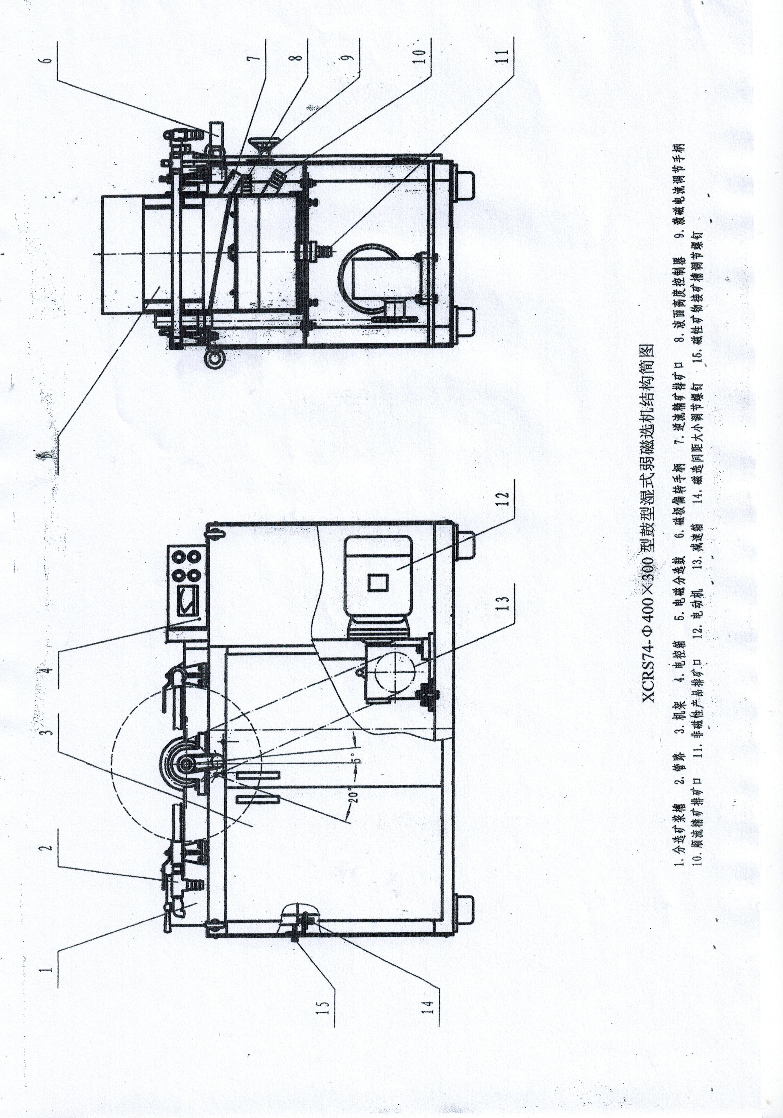
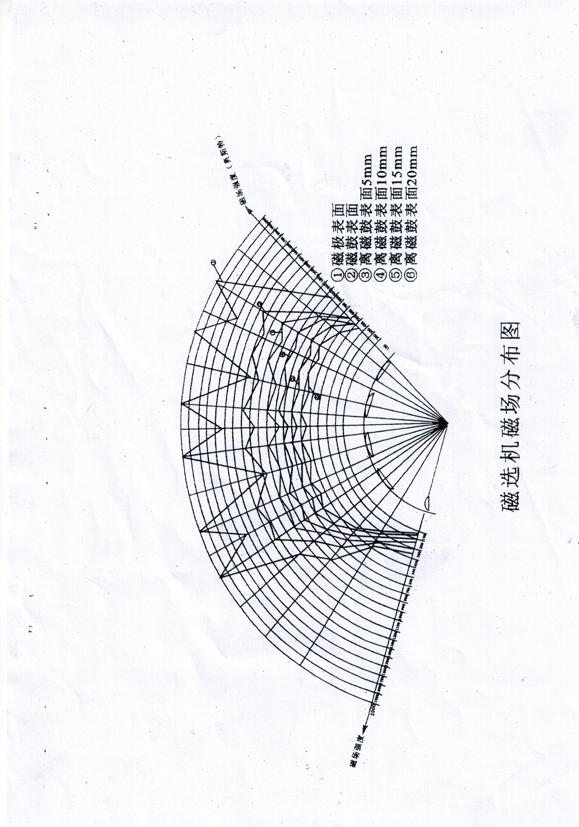
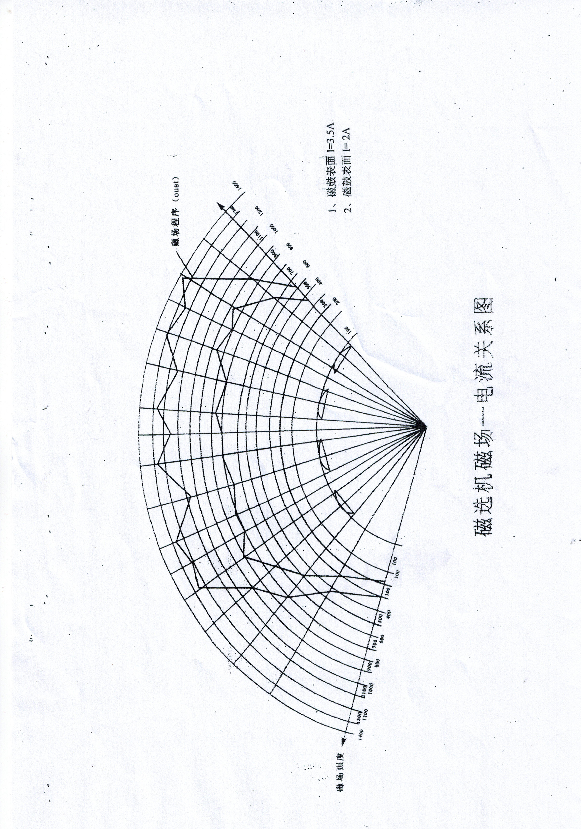
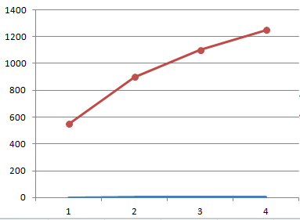

XCRS74-400×300 model

1. use
XCRS drum-type wet weak magnetic separator is mainly used in metal beneficiation laboratory. It uses the wet method to conduct magnetic selection of fine grain strong magnetic ore, and the selection form is smooth flow. XCRS drum wet weak magnetic separator is small in size, light in weight, simple operation, convenient maintenance. The equipment is not suitable for ore-dressing test with corrosive liquid, and should be reliably grounded.
2. technical specifications
order number | name | unit | numeric value
1 | Magnetic drum effective size | mm | 400*300
2 | Magnetic field strength of the magnetic drum surface | M T | 125
3 | Magnetic drum speed | r/min | 25
4 | rated operational current | A | 0-4
5 | Magnetic electrode coil temperature rise | ℃ | ＜100
6 | Maximum particle size | M m | 2
7 | supply voltage | V | 380 Three-phase and four-wire lines
8 | frequency | Hz | 50
9 | weight | K g | About 300
3. Structure of the brief introduction and features
The XCRS drum type wet weak magnetic separator is composed of the main body of the magnetic separator and the drum type power supply. The main body of the magnetic concentrator mainly includes: frame, magnetic drum, ore tank, water spray pipe, transmission device and feed tank.
The drum power supply is a separate silicon bridge rectifier power supply, whose output is adjusted through the voltage regulator handle.
1, frame: made of Angle steel welding, for the supporting part of the whole machine.
2, magnetic drum: it is equipped with four exciting magnetic coils and magnet core, and an additional magnetic pole without exciting magnetic coil on the side of the discharge, to facilitate ore discharge, the five fan fixed in the magnetic pole

On the spindle, the spindle is fixed on the frame through the support bearing tile, and the cylinder is made of non-magnetic material aluminum and no
Made of rust steel, fan coil connection to cause the alternating polarity of the magnetic field in each magnetic pole, the ore is flipped up to 180 degrees through each magnetic pole, under the action of magnetic stirring, can improve the quality of magnetic products. At one end of the spindle, it is a square extension structure, which can use a hand plate to rotate the magnetic pole of the magnetic drum around the axis to meet the selection needs of different minerals.
3, transmission device: installed at the bottom of the side of the rack, in order to reduce the center of gravity, transmission part consists of three ac motor and worm wheel, worm gearbox, the output of the transmission through the chain to magnetic drum, drive magnetic drum rotation (pole is not turn), the speed of the drum for the constant speed 25 RPM, magnetic drum rotation direction is consistent with ore direction.
4. Mining tank:
It is made of aluminum and stainless steel plate welding and fixed on the rack on the feed side of the mine tank and the lower part of the concentrate tank for connection.
5. Spray pipe:
A copper pipe with a hole installed on the rack is connected with the indoor water source for flushing the concentrate on the magnetic drum; the water spray angle can be adjusted by rotating the water pipe.
6. Paving deposit box:
The box is made of stainless steel plate welding, which is to ensure the uniformity of feeding.
4. Installation, use, maintenance, and precautions
(1) Installation
After the machine is opened, it can be placed on the general workshop or laboratory floor, first clean the packaging oil, check whether the welding of fasteners and electrical components is loose and fall off, considering the inspection and maintenance of other supporting equipment, but also consider the discharge of power supply, tap water and waste water. After connecting the three-phase four-wire power supply, try driving, rotate the magnetic cylinder in the direction shown by the red arrow, and use each part after observing the normal condition. If the magnetic cylinder is found to convey to the opposite, the transmission motor three wiring can be arbitrarily replaced with two of them.
(2) Use
1. turn on the power supply, turn on the power switch, when there is a magnetic current output, the power indicator is on.
2. Turn on the running switch, and the magnetic drum rotates in the normal direction.
3. Rotate and adjust the position of the magnetic pole, make the fan magnetic pole in the required position, adjust the voltage regulator handle, so that the output DC current in the required value.(Limit use value of 3.5A)
4. Feed the mine and open the water spray pipe at the same time.(Water pressure is <0.1 Mpa).
5. After the feeding, put the running knob switch in the "break" position, make the rotating cylinder stop rotating, close the recoil water pipe and water spray pipe, and then row the tailings.
6. Drainage of concentrate.
7, cut off the exciting magnetic power supply, cut off the magnetic power supply.
8. Rinse the tailings tank again, and combine the two products into concentrate products.
9. After the operation, conduct a thorough rinse; the regulator handle is zero, cut off the power switch, and then cut off the power supply of the whole machine, and the first test is finished.
(3) Maintenance:
1. Before use, check the rotating part of the equipment, electrical components and other parts, carefully, and make sure that the equipment is in normal condition.
2. The continuous working time of the equipment shall not exceed 3 hours.
3. The lubricant in the reducer shall be replaced once every six months.
4. In the process of using the equipment, if the insurance is broken, it must check for short circuit before replacement; it is strictly prohibited to use unqualified insurance pipe or connect connected with copper wire.
(4) Note:
It is strictly prohibited to cut off the power supply during the high current operation of the equipment. The power supply must be turned off only after the ammeter is adjusted to zero position to prevent possible dangerous situations such as circuit and motor damage.

